Intro to Radar Systems HW11

11-1)

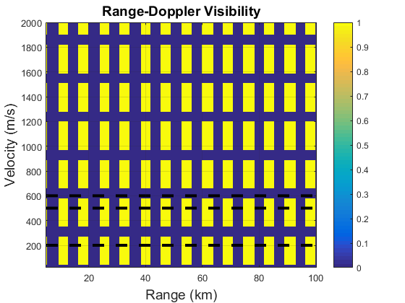

The targets traveling 200 m/s and 400 m/s are visible, but the target moving 600 m/s is not visible.